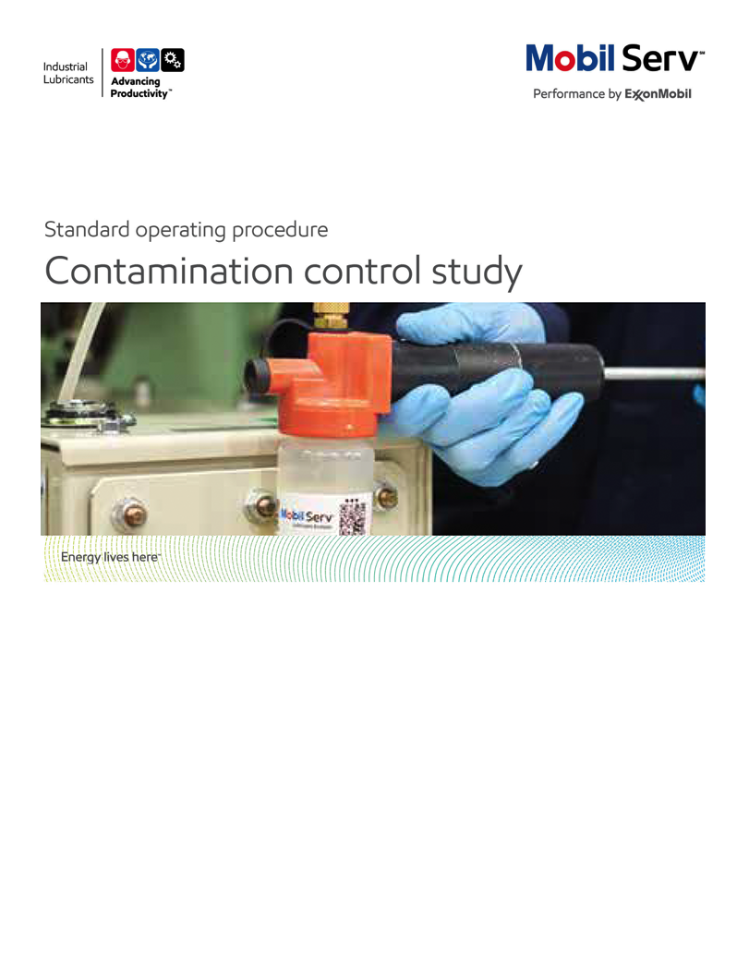

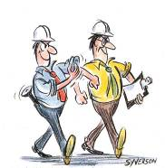 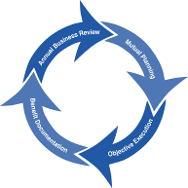

**Standard Operating Procedure** **(SOP)**

**Read all of the steps in this SOP before beginning work.** **Follow customer labor requirements (i.e. respect Union work)**

|  |  |  |  |  |  |
| --- | --- | --- | --- | --- | --- |
| **SOP: OIL CLEANLINESS & CONTAMINATION CONTROL STUDY** | | DATE  8/10/2015 | ⌧ NEW  REVISED  ___ Number | | PAGE 1 of 10 |
| TYPICAL CUSTOMERS  Manufacture, Plastics, Cement, Mining, Sugar, Energy, Pulp & Paper, etc. | WORK TYPE  Contamination Control/Cleanliness Study | WORK ACTIVITY (Description)  Perform a oil cleanliness & contamination control study in order to reduce contamination inside the equipment,and provide best practice guidelines. | | | |
| **DEVELOPMENT TEAM** | **POSITION / TITLE** | **REVIEWED BY/DATE** | | **POSITION / TITLE** | |
| Javier Carrillo (2013) | Col Lube Engineer | Luciano Macias (2013) | | South America Chief | |
| Manuel Escalante (2013) | Perú Lube Engineer | Gilles Delafargue (2015) | | Global FES Advisor | |
|  |  | Tom Schiff (2015) | | Global FES Manager | |
| **PLEASE UTLIZE ATTCHED GENERAL JSA AS GUIDANCE AND, IF YOU HAVE DONE A SITE SPECIFIC JSA.**  **PLEASE ASSESS YOUR OWN CONDITIONS OR SPECIFIC SAFETY REQUIRMENTS OR 3rd PARTY SITES, AND BE SAFE:**  [**http://fllubes.na.xom.com/docs/safety/jsa/JSA_Equip_System_Contamination_Control_Study.xls**](http://fllubes.na.xom.com/docs/safety/jsa/JSA_Equip_System_Contamination_Control_Study.xls)  [**http://fllubes.na.xom.com/docs/safety/jsa/Lubricant%20Room%20Storing%20and%20Handling%20Inspection.xlsx**](http://fllubes.na.xom.com/docs/safety/jsa/Lubricant%20Room%20Storing%20and%20Handling%20Inspection.xlsx)  [**http://fllubes.na.xom.com/docs/safety/jsa/JSA_Conducting_Lubrication_Survey_%20Mobile_Equipment.xls**](http://fllubes.na.xom.com/docs/safety/jsa/JSA_Conducting_Lubrication_Survey_%20Mobile_Equipment.xls)  [**http://fllubes.na.xom.com/docs/safety/jsa/JSA_Driving_on_customer_sites_quarries_mines_woodyards.xls**](http://fllubes.na.xom.com/docs/safety/jsa/JSA_Driving_on_customer_sites_quarries_mines_woodyards.xls) | | | | | |
| **EQUIPMENT INDEPENDENT OF JSA DESIRED DOCUMENTATION** | | | | | |
| ⌧ CLIPBOARD OR IPAD / TABLET PC  ⌧ IR GUN  ⌧ FLASHLIGHT(with safety hand string)  ⌧ SAMPLE THIEF, BOTTLES & LABELS  ⌧ RAGS LINT FREE  ⌧ CAMERA (with safety hand string) | | ⌧ DATE OF – (ESN) Engineering Service Notice as a leave behind  ⌧ OIL ANALYSIS REPORT (SIGNUM).  ⌧ SERVICE INSPECTION REPORT.  ⌧ FINAL – (ESR) Engineering Service Report OR PROPOSAL WITH TOTAL COST OF OWNERSHIP (TCO )SAVINGS  **OTHER (SPECIFY**)  ⌧ INSPECTION SPREADSHEET  ⌧ PLANT ANALYSIS BOOKLET | | | |
| **TIME ESTIMATED TO COMPLETE THIS TASK NUMBER OF PEOPLE TO PERFORM THIS TASK** | | | | | |
| Typically one day pre study preparation; one two two days on site (some studies can be extensive lasting several days to cover all areas of a facility); ½ to one day analyzing data (e.g. lab cleanliness), formulating recommendations, etc. | | Typically one qualified Field Engineer with support from customer personnel; for large projects more Field Engineers may be needed | | | |
| **FREQUENCY TO PERFORM THIS TASK SKLLS REQUIREED TO PERFORM THIS TASK** | | | | | |
| DEPENDS ON CUSTOMER COMMITMENTS. ALSO DEPEND ON THE QUANTITY OF EQUIPMENT SELECTED BY THE CUSTOMER. EVERY WEEK YOU CAN INSPECT THE EQUIPMENT AND FOLLOW THE RESULTS. | | ⌧ MECHANICAL APPTITUDE.  ⌧ PRODUCT KNOWLEDGE.  ⌧ FILTRATION KNOWLEDGE.  ⌧ EXPERIENCE WITH BREATHERS.  ⌧ CONTAMINATION CONTROL EXPERIENCE.  ⌧ TYPICAL PROBLEMS WITH CONTAMINATION.  ⌧ CONDITION EQUIPMENT DETAILED OBSERVATION: ABNORMAL NOISE, HIGH TEMPERATURES, LEAKING, OVERLOAD, AEREATION, VIBRATIONS.  ⌧ WAREHOUSE AND STORAGE INSPECTION EXPERIENCE.  ⌧ SAMPLE TAKING EXPERIENCE.  ⌧ OIL ANALYSIS AND INTERPRETATION EXPERIENCE. | | | |
|  | |  | | | |
| **JOB COMPETANCIES REQUIRED TO PERFORM THIS TASK** | | **TRAINING REQUIRED TO PERFORM THIS TASK** | | | |
| ⌧ UOA INTERPRETATION  ⌧ SAMPLING.  ⌧ BASIC LUBRICATION IN: GEAR BOXES AND REDUCERS, HYDRAULICS SYSTEMS, TURBINES, BEARINGS, COMPRESSORS, ENGINES, ETC.  ⌧ FILTRATION & DIALYSIS.  ⌧ SPIN SELLING  ⌧ TCO / BENEFIT REPORT WRITTING  ⌧ LUBE STORAGE, HANLDING & DISPENSING GUIDANCE. | | ⌧ Gears, Bearings, & Couplings eLearn  ⌧ Hydraulic Systems eLearn  ⌧ Plant equipment inspection training (file attached)  ⌧ Product knowledge and Recommendations  ⌧ UOA Interpretation (Cleanliness).  ⌧ Filtration & Dialysis.  ⌧ Contamination control best practices.  ⌧ Site specific safety training | | | |
|  | |  | | | |
| **OTHERS RESORCES OR RELATED INTEREST SITES** | |  | | | |
| ⌧ TECHNICAL HELP DESK (THD) ([tsc.amerias@exxonmobil.com](mailto:tsc.amerias@exxonmobil.com))  ⌧ www.mobilindustrial.com  ⌧ [www.looble.com](http://www.looble.com) | | ⌧ LTS (LUBRICANT TECHNICAL SUPPORT) | | | |

**PURPOSE** – To describe the process for developing an Oil Cleanliness/Contamination Control Study in a new or an an existing customer. The main objective through the Oil cleanliness & contamination control study is to monitor the oil condition along the supply chain (from warehouse/tanks to different equipment) identifying sources of contamination in order to propose improvements for keeping clean the oil and to increase equipment life. From this study we should also propose / encourage best practice on the way to manage step by step cleanliness at the application , i.e. (1)set up what cleanliness is required at the application (2)ensure that filtration or centrifugation units are adequately selected to match and keep the level of cleanliness required and (3)identify and propose actions to avoid or minimize on-site oil contamination.

The documents provided in attachment of this SOP should help provide documented guidelines on best practices to apply.

|  |  |
| --- | --- |
| **LOCATION** | **JOB STEPS** |
| Prior your call, collect customer information. | * Identify customer sector and prep for suffering points for this industry (Example, Cement: a lot of contamination). * Determine why the Cleanliness Study is needed. What is the goal of the customer?. Specifically identify high equipment and lubricant replacement cost areas. * Based on the equipment used at the customer facility and equipment reliability performance help the customer set their cleanliness goals (target ISO numbers) * Get preliminary information: Equipment Name, Equipment Asset Numbers, Current Lube Routes, Current Lubricant used, OEM, Model, Lubrication practices ( How they apply the lubricant, how they handle the oil, how they take the samples, what tool do they use to apply the lubricant), warehouses used for storage lubricants and what kind of filtration they use. * Get process diagrams to understand customer equipment and nomenclature. * Consult support information and owner & OEM manuals. * Collect all used oil analysis information they have about the specific equipment. Ask for cleanliness information. Ask for the laboratory they use. * Get organization diagrams in order to know what people is responsible for lubricant application, taking samples, oil filtering, oil storage, etc. * Ask customer for frequency of oil drain interval change and top off oil. * Ask customer for visiting the equipment, the oil warehouse and tool warehouse (Some customers use one warehouse for sealed drums and other for drums that already open). * Ask customer for personal protection equipment, safety training, etc. you will need previous to visit different locations.. * Be ready with SPIN questions regarding the equipment: Filtration, oil drain interval, samples, personnel, tools, etc. |
| Equipment inspection | * Be accompanied by a customer representative. * Be aware of potential hazards close to the equipment and follow safety procedures/JSAs. * Identify the objective of the critical (high replacement cost, high downtime impacts, safety impacts, etc.) equipment in the manufacturing process. Confirm cost impacts in the “as is” condition. Best practice is to consult with customer storerooms, customer KPIs, customer Computer Maintenance Management System (CMMS), customer rebuild shops, contractors/off site repair shops, etc. to gain insights/information on the current costs/impacts. * Review with the customer the path of the lubricant inside the equipment. Identified all the point that are in contact with the environment (Where the oil is apply, the sample is taken, vents, manholes, caps, etc.). * Take notes of the brand and models of the equipment and the components. See if there are filters attached to the equipment. Ask for the information about those filters (Brand, Model, Beta Rating, filter element change frequency). Ask how they know when they have to change the oil. * Also take notes and ask questions regarding:   + OEM recommendations   + current lubricant in use   + maintenance frequency   + lubrication periods   + quantities applied, leakage issues   + oil drain Interval   + application method   + used oil analysis. * See if there is any label attached to the equipment that show basic information like oil used, date of oil changed, refill, etc. How they use visual management to avoid cross-contamination. * If it is possible, watch how a technician apply the lubricant and take samples. Identify potential issues. Best practice is to sample the lubricant from each transfer point starting with the inboand lubricant (from the drum/container or bulk tank, to lube storage facilities, to lube transfer equipment, and finally the point of equipment application and the lubricant in the equipment itself. * To help evaluation filtration effectiveness, take a sample before the filter and after the filter. Take the samples and send to the laboratory (Ask for the data of the sample). * See if there is any dialysis equipment. Take notes of brand, model, filters quantity, beta and change frequency. If it is possible ask the customer if you can see how they dialyze the oil (Look for potential issues). Take samples before and after the dialysis. * See if there is any particle counter attached to the equipment. Ask for the information of this equipment (Measure range, calibration, maximum size it can measure). Use this information as well as reviewing their UOA lab analsysis to evaluate the effectivensss of their detection methods. * Review each critical piece of equipment (especially those with cleanliness levels above their goals and poor equipment reliability/higher cost history) for the following:   + How lubricant is dispensed in the equipment   + Filtration equipment and do they meet the needs of the system to reach cleanliness goals and are they properly functioning (especially vacuum dehydrators, centriguges, etc.)   + Reservoir and lube return line breathers for proper protection from ingression; also evaluate if the customer is maintaining them well   + Inspect the inside of the reservoir on the underside of the top to see if water condensation is present; evaluate if the reservoir has proper ventilation and in extreme environments dry air or nitrogen padding   + Inspect the bottom of the reservoir by using a sludge judge or if needed pull a sample from the bottom of the reservoir to check for excessive water/debris   + If needed on machine outage days, inspect drain lines for excessive debris and/or bearings/gears for excessive varnish, rust, debris   + If unsure of the nature/source of lubricant system contamination consider using LTS to identify the material to help generate the optimium improvement recommendations   + For systems with varnish evaluate the need for a resin/dieletric by pass filter system   + Evaluate if some lube systems would benefit from by-pass periodic cleaning (typicaly based on UOA analysis) and limitations to install permanent lube cleaning devices * Use IR Gun, flashlight and proper equipment to note for future projects:   + operating temperatures   + operating conditions   + lubricant leakage issues   + vibrations   + contaminant entry points   + unusual odors, fog, vapors, environment, abnormal conditions   + Take photographs of the equipment to highlight improvement opportunities (ask for permission previously) |
| Storage and Dispensing Containers | * Create a list of current lubricants, delivery container sizes and usage by department using storeroom, lube storage areas and lube cabinets. * Observe the warehouse used for storage the oil ( Ceiling, floor, walls). Ask the customer if there is only for oil, how they prevent contamination in the room. * Observe types of containers (Bulk, drum or pail). * Observe the equipment used to deliver the oil (Neumatic pump, manual pump, etc.). See if there is one pump for one kind of oil. Observe how the tip of the gun is. Identify potential issues. * Observe if there is the area is identified for types of oils. * Observe if they use breathers on the drums or the bulks. * Ask if they dialyze the new oil. Ask for used oil analysis information . If is is possible take a sample before and after the dialysis. Ask for the information of the equipment use to dialyze the oil (Brand, Model, quantity of filters, beta, change frequency). * Observe types of containers for preventing ingression of contaminants (are they sealed, are they labeled). Are they use funnel? How clean is the funnel? * Review if containers are dedicated by product * Observe the oil container labeling ( Drums, pails, small containers). How they use visual management to avoid mistakes. * Make a general note on housekeeping of containers and materials management. * Observe the tools they use to apply the lubricant. Are they labeled?. Are they proper storage?. * Take photographs if you have permission.   At the end of the visit write an Engineering Service Notice to the customer, highlighting the main items covered, agreements next steps, and timeframe |
| Home Office – analyzing all data (Information Analysis) | * Send samples to the lab. Ask for particule counter analysis. * Confirm the lubricant used in the equipment: Technical Support Center (TSC), Looble, EMEBS, and/or your Field Engineer. * Consult OEM Manuals. Compare actual conditions vs. OEM cleanliness recommendation. * Consult with filtration specialist. Confirm if filters used are right for the application. * Ask your colleagues about similar situations and how they were solved. * Look for best practices in contamination control. * Review in Inside Sales – Technical – Model Reports and the VDR site for similar applications, products and how others have built a benefit report. * Review the photos and mark the issues. Find photos with best practices in order to compare. |
| Prepare the ESR | * Using the 3D Report Writer format, prepare the ESR. * Apply the applicable TCO Categories: Revenue, Assets, Process, Expenses and Others. * Always consider the costs to implement the improvement recommendations to obtain the true TCO. Do not only state the positive cost side of the recommendations but include the investiment costs (e.g. new filter system, new labor needed, etc.) * Use photos to explain your findings. * Provide guidelines about Best Practices |
| Guidelines about Best Practices | * set up what cleanliness is required at the application   (see table in attachment)   * ensure that filtration or centrifugation units are adequately selected to match and keep the level of cleanliness required (see table in attachment) * identify and propose actions to avoid or minimize on-site oil contamination.(storage and Handling & contamination avoidance Best Practices) |
| Set a follow up meeting with customer to review draft. | * Confirm with the customer the findings and explain why you think are potential issues. Use support data like used oil analysis, OEM recommendations and other customer best practices. * Explain your recommendations and the necessary changes to meet the goal. * Explain the next steps to achieve this value and express as opportunities for improvement. |
| Manage implementation and expand relationships | * Get customers cooperation to implement your recommendation * Offer your technical post-sale expertise expand relationships |
| Feedback about this SOP - send to Field Engineering Advisor/Supervisor |  |

**Equipment Inspections:**

* Take notes about equipment information: Equipment Name, Equipment Asset Numbers, Current Lube points, Current Lubricant used, OEM, Model, series, etc.
* Identified the objective of the equipment in the manufacturing process.

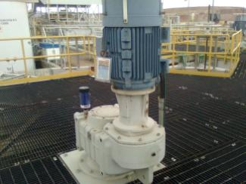

See if there are Indentification labels

Indentify Breathers

Identify levels viewfinders

Take notes about how clean are the equipments

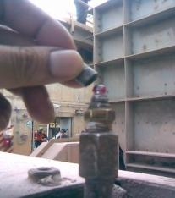

Identify any source of Contamination that can increase the cleanliness of the oil inside the equipment.

Identify protection accesories.

See if there is a possibility to watch an operator take a sample or change the oil. Identify any opportunity to improve.

**Storage inspection.**

* Take notes about quantity of oils used in the plant.
* Identify if the storage is for close or open drums or pails.
* Identify if the warehouse is close or is in an open space.

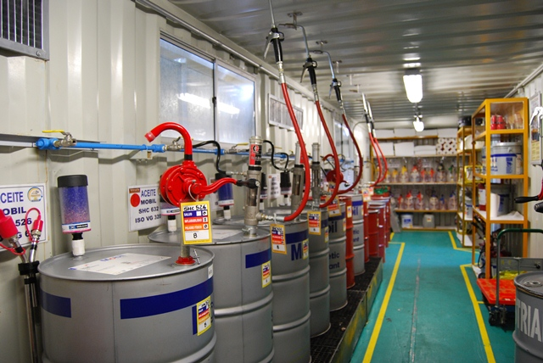

See the tip of the gun for any trail of contamination

Identify if there is one pump per product.

Take notes about how clean is the warehouse

Indentify Breathers

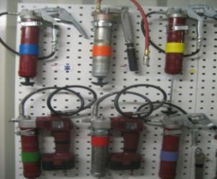

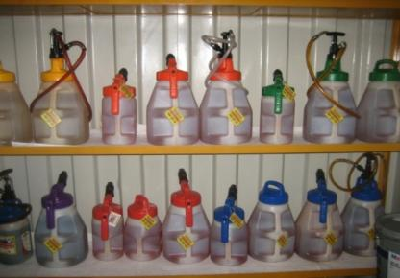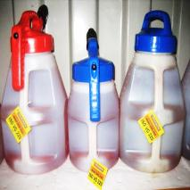

Fuente: MYSRL

How the customer avoid cross contamination

Indentify the type of packaging used for fillings

**Attachments**

[**handling-and-storing-lubricants tech topic**](http://www.mobilindustrial.com/IND/English/Files/tt-handling-and-storing-lubricants.pdf)

[**Lubricant Storage Basic Guide**](http://ishareteam2.na.xom.com/sites/LSSG031/TechResources/Tech%20Resources%20Docs/Lubricant%20Storage%20Basic%20Guide.pdf)

[**Basic Lubricant Cleanliness Guide Charts**](http://ishareteam2.na.xom.com/sites/LSSG031/TechResources/Tech%20Resources%20Docs/Basic%20Cleanliness%20Guide%20Charts.docx)

[**Check list for on site cleanliness inspection**](http://ishareteam2.na.xom.com/sites/LSSG031/TechResources/Tech%20Resources%20Docs/Check%20list%20for%20on%20site%20cleanliness%20inspection.xlsx)

**DOCUMENTING YOUR WORK** – Product recommendations (typically for Major/PES accounts and not for routine recommendations) can be a significant way to assist customer reach their equipment reliability goals by addressing potential or actual suffering points. Persons making product recommendations should document the recommendation (technical rationale), case for action, follow up recommendations and their value using Mobil Serv Report Writer (3D) and TCO approach.

TCO is a process to quantify improved profit through the implementation of an effective lubrication program. In order to document savings involved in a partnership between the customer and Mobil Industrial Lubricants, the following categories of value-added savings will be reviewed: Revenues, Assets, Processes, and Expenditures

The TCO Worksheets are the preferred format to include in your report. Proper placement is an Appendix. Additional guidance will incorporate our messaging of TCO to include Sustainability, Safety and Productivity relationships. Quantify these costs on an annual basis. We should use customer cost/impact data. If the customer does not know the numbers then utilize estimates from experience or other resources (repair shops, OEMs, etc.) then have the customer agree to the numbers/impacts. Both Benefits and cost avoidance should be considered.

Expenditure Reduction - reduced equipment and/or lubricant purchase costs are the most typical expenditure savings. These may result from the offset of extending lube application intervals from the previous purification/cleanliness “as is” condition against the increased price of Mobil products flagships and premium or other recommendations to modify the lubricated equipment, lubricant delivery, lubricant purification systems, etc.)

Process Improvement - the hourly wages (including burden) for personnel to perform existing tasks e.g. replaces the lubricant, or repair equipment reduced in part by the contamination control recommendation (s), are typical Process improvement savings. If equipment replacements or lubricant change outs are reduced, use these to determine Process improvements. If lubricant usage is reduced, use the time to handle drums and the time to dispose of used lube to determine Process improvements.

Revenue Enhancement - any equipment failure, anticipated timely via Used Oil Analysis particle counting follow up for example, may be repaired during normal maintenance and so reduce the potential for downtime. “Unscheduled Downtime”, results in lost production and most often, scrapped parts or material. This may allow the customer to plan for a replacement during a planned outage instead of an emergency shutdown. Savings due to production losses avoided may be significant.

Asset Improvement - use the customers "cost to carry" inventories. This is used from the Expenditures components for example, if you reduce the quantity of lubricant needed, take that amount cost and multiply by the "cost to carry" to determine the Asset value.

Safety Improvement – this is typically man-hours of avoided equipment interface exposure by increasing time between lubricant application/changes, reduced equipment repairs, etc. This could also include incidents caused by slips but do not document improvements in actual number of accidents or incident rates but rather the potential to impact those statistics.

Environmental Improvement – this is typically quantified by reduced lubricant volume disposed or reduced CO2 emissions

Refer to Expenditure Reduction, Process Improvement, Revenue Enhancement, and Asset Improvement to develop TCO. The Total Cost of Ownership (TCO) Database has many equipment typical costs in it, or consults with the OEM or equipment distributor to finalize your TCO. In all cases, ensure your customer agrees with the cost estimates. Sometimes you may need to suggest an estimated cost and get the customer to agree/negotiate to acceptable figures.

[TCO Database](http://intratta.na.xom.com/emdn/sbps/technical/TCO_Databases.html)

Include any “negative” components of TCO from your recommendations (which should be rather considered as an “investment”);extra cost of lubricant first fill (synthetic Vs mineral), new lube systems, filtration, water removal, enhanced predictive monitoring, increased labor (to do the job correctly the first time), new equipment; e.g. to replace under sized equipment.

**Model Reports**

<http://ishareteam3.na.xom.com/sites/LSSG035/VDR%20Document/ESR%20-%20US%20Steel%20-%20MES%20Audit%20-%202013%20-%20Complete.pdf>

<http://ishareteam3.na.xom.com/sites/LSSG035/VDR%20Document/Technical%20Service%20Report%20-%20Cleanliness%20Study.pdf>

<http://ishareteam2.na.xom.com/sites/LSSG031/TechResources/Tech%20Resources%20Docs/Mining_and_Construction_Cleanliness_Study.pdf>

<http://ishareteam2.na.xom.com/sites/LSSG031/TechResources/Tech%20Resources%20Docs/Mining_and_Construction_Engineering_Recommendation_filtration_example.pdf>

<http://ishareteam2.na.xom.com/sites/LSSG031/TechResources/Tech%20Resources%20Docs/Filtration%20Recommendation%20-%20Paper.pdf>

<http://ishareteam2.na.xom.com/sites/LSSG031/TechResources/Tech%20Resources%20Docs/Filtration_Engineering_Rec_Paper.pdf>

<http://ishareteam2.na.xom.com/sites/LSSG031/TechResources/Tech%20Resources%20Docs/Paper%20Filtration%20Recommendation.pdf>

<http://ishareteam3.na.xom.com/sites/LSSG035/VDR%20Document/2013%20MeadWestvaco%20Contamination%20Control%20Summary%20ESR.pdf>

<http://ishareteam3.na.xom.com/sites/LSSG035/VDR%20Document/Plant%20audit-%20International%20Paper%20-%20APPM%20-%20ESR.docx>

<http://ishareteam3.na.xom.com/sites/LSSG035/VDR%20Document/2014%20International%20Paper%20Company%20Rome%20Signum%20Summary%20Engineering%20Service%20Report.pdf>

* **Contamination Control & Filtration Basics Reference Material**

<http://ishareteam2.na.xom.com/sites/LSSG031/TechResources/Tech%20Resources%20Docs/Contamination%20Control%20Basics.pdf>

<http://ishareteam2.na.xom.com/sites/LSSG031/TechResources/Tech%20Resources%20Docs/Filtration.ppt>

<http://www.pall.com/main/industrial-manufacturing/pocket-book-contamination-and-filtration-42674.page>

<http://ishareteam2.na.xom.com/sites/LSSG031/TechResources/Tech%20Resources%20Docs/Beta%20Ratio%20Technical%20Bulletin.ppt>